Travel to the London Youth Games Cross-Country Championships at Parliament Hill, Hampstead Heath, London
on Saturday 19th November 2022
(Event’s Post Code NW5 1QR – note this is for Highgate Rd, to the course, not for the Car Parks)

Parking at Parliament Hill Fields - Hampstead Heath, North London is limited so please allow plenty of time. There are two car parks, available for the general public, one is at the bottom of East Heath Rd (approx. NW3 1BN carpark on East Heath Road) and the other is at Jack Straws Castle car park (North End Way - NW3 7ES) at the top of the East Heath Rd. They both hold a maximum of 200 cars; Pay & Display Car Park prices 0-2 hrs is £5.00; 2-4 hrs is £10, additional each hour charge (above 4 hrs) is £9.
Side roads around Parliament Hill Fields are busy and in general residents parking only, so to help you we list various routes and ways to get you to the venue. IMPORTANT - READ ALL BELOW CAREFULLY.

Coaches, Minibuses & People Carriers
These will be allowed to park on the Heath near to the bottom of East Heath Road (approx. NW3 1BN carpark on East Heath Road). Clubs travelling by Coach or Minibus or People Carriers 6 seats or more will be guaranteed a parking spot at the East Heath Coach & Minibus parking area by forwarding the separate sheet along with a fee of £30 for a Coach, and a £20 for a Minibus or for People Carrier (6 seats or more).
On sending your application with a cheque made payable to The City of London, you will be sent a parking pass for display on the vehicle windscreen. If you do not have cheques, you can make a payment by card over the phone Mon-Fri, 9.30am-12.30pm and 1.30pm-3.30pm; Tel: 020 7332 3774. In this case, please email your application form to hampstead.heath@cityoflondon.gov.uk before you make the call for card payment.

Cars from the Midlands and North
Drivers are advised that they should park away from Parliament Hill (PH) and take public transport to PH Bellow suggests parking near Brent Cross, London Transport Station, either on the side roads at the Station or in the nearby Shopping Centre.
Directions: Approach London visa the M1. Turn on to the A406, North Circular Rd going East. Follow this a short way and then bear left and follow signs A41 (Central London). Under the Brent Cross flyover proceed to A41, just before joining the A41 take the second turning left into Highfield Rd. Brent Cross Station on the Northern Line is on the left and street parking is allowed in the area. Take the train to Belsize Park and walk about 1 mile to Parliament Hill. Allow time for this. The Richmond Station is about 400m away and trains go to Gospel Oak every 20mins. The journey from Richmond to Gospel Oak takes about 30mins.

Cars from South and West
Again, drivers are advised to park away from PH and perhaps take the London Overground Service to Gospel Oak which is less than 400m from the venue.
Directions: On arriving on the outskirts of London get onto the M3 and continue until it merges with the A316 and proceed past Twickenham Rugby ground on the left. Continue until Old Deer Park is reached and opposite the Park there is a pay and display car park where vehicles can be left all day. The Richmond Station is about 400m away and trains go to Gospel Oak every 20mins. The journey from Richmond to Gospel Oak takes about 30mins.

Cars from the South East and East
Clubs from these areas have been attending the Southern Championships at PH for many years and know the parking situation. The advice is to park away and use public transport. Kentish Town Station is only a 15-minute walk from the venue, while Gospel Oak can be reached from North Woolwich and many other Stations on the route.

Public Transport into London
If you are travelling to Kings Cross or Euston, you can get to PH via Bus or Underground Train. The 214 Bus route goes from Moorgate and Kings Cross Stn to Highgate Rd, (Bus stop William Ellis School - near Parliament Hill) every 10mins, this journey takes about 30mins. Other bus routes stopping at Highgate Rd include the Bus 88 (comes from Clapham, stopping at Vauxhall train station); and the C11 which comes from Brent Cross where there a large Shopping Centre and Car Parking to Archway. Underground Stations within walking distance of PH are Tufnell Park or Kentish Town less than a mile away and Belsize Park or Hampstead about 1 mile walking distance. These are both on the Northern Line and can be got to from any of the main railway stations in London.

Club Tents will be allowed to be erected by the Bandstand at Parliament Hill, drop off for these will be at the Highgate Road (NW5 1QR) entrance, NO cars will be allowed on site.
The Registration Marque is along the path from Highgate Rd entrance and the Club Tent area.
Please note- we are on inside ULEZ zone.
Coach / Minibus / People Carrier

Parking Application form

East Heath car park – NW3 1BN

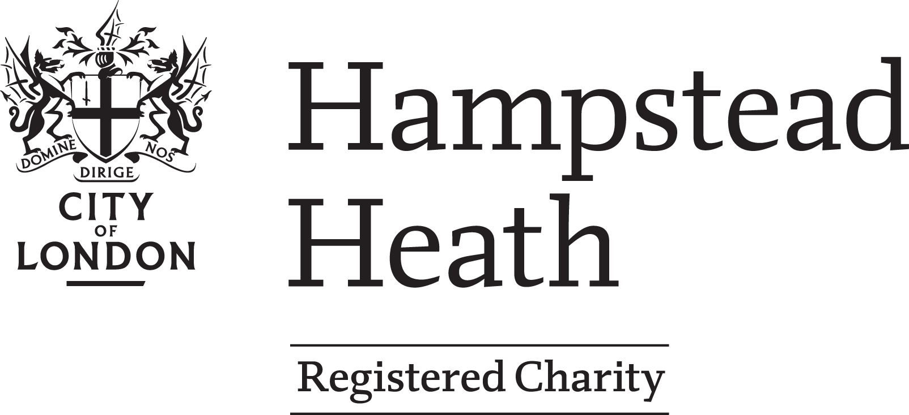

To: Mr Paul Maskell
Leisure & Events Manager
City of London / Hampstead Heath
Parliament Hill Staff Yard
Highgate Rd
London
NW5 1QR

Tel: 020 7332 3774
E-mail: hampstead.heath@cityoflondon.gov.uk

On behalf of___________________________________________________________________Club

I would like to apply for

a Coach…… seater Pass £30

a Minibus Pass £20

a People Carrier (6 seats or more) £20
(Please tick as applicable)

Enclosing with this form a cheque, payable to The City of London

or I will pay a fee of ________ by card by phone (preferably) by calling: 020 7332 3774, Mon-Fri 9.30am-12.30pm and 1.30pm-3.30pm,

for the LYG Cross-Country Championships on Saturday 19th November 2022

Please return the form in advance of payment. Please write in Subject please write the name of your club.

Please note: the closing date for applications is Friday 11th of November 2022.
----------------------------------------------------------------------------------------------------------------------------------

The pass should be sent to ……………………………………………………………………

Address ……………………………………………………………………

……………………………………………………………………

Post code: …………………….

Name/Surname of sender ___________________________________

Phone No __________________________E-mail_________________________________ ____

The Pass must be displayed on the windscreen of your Coach, Minibus or People Carrier, failure to do so will exclude the Vehicle from parking at East Heath.

We look forward to welcoming you to Parliament Hill Fields.

