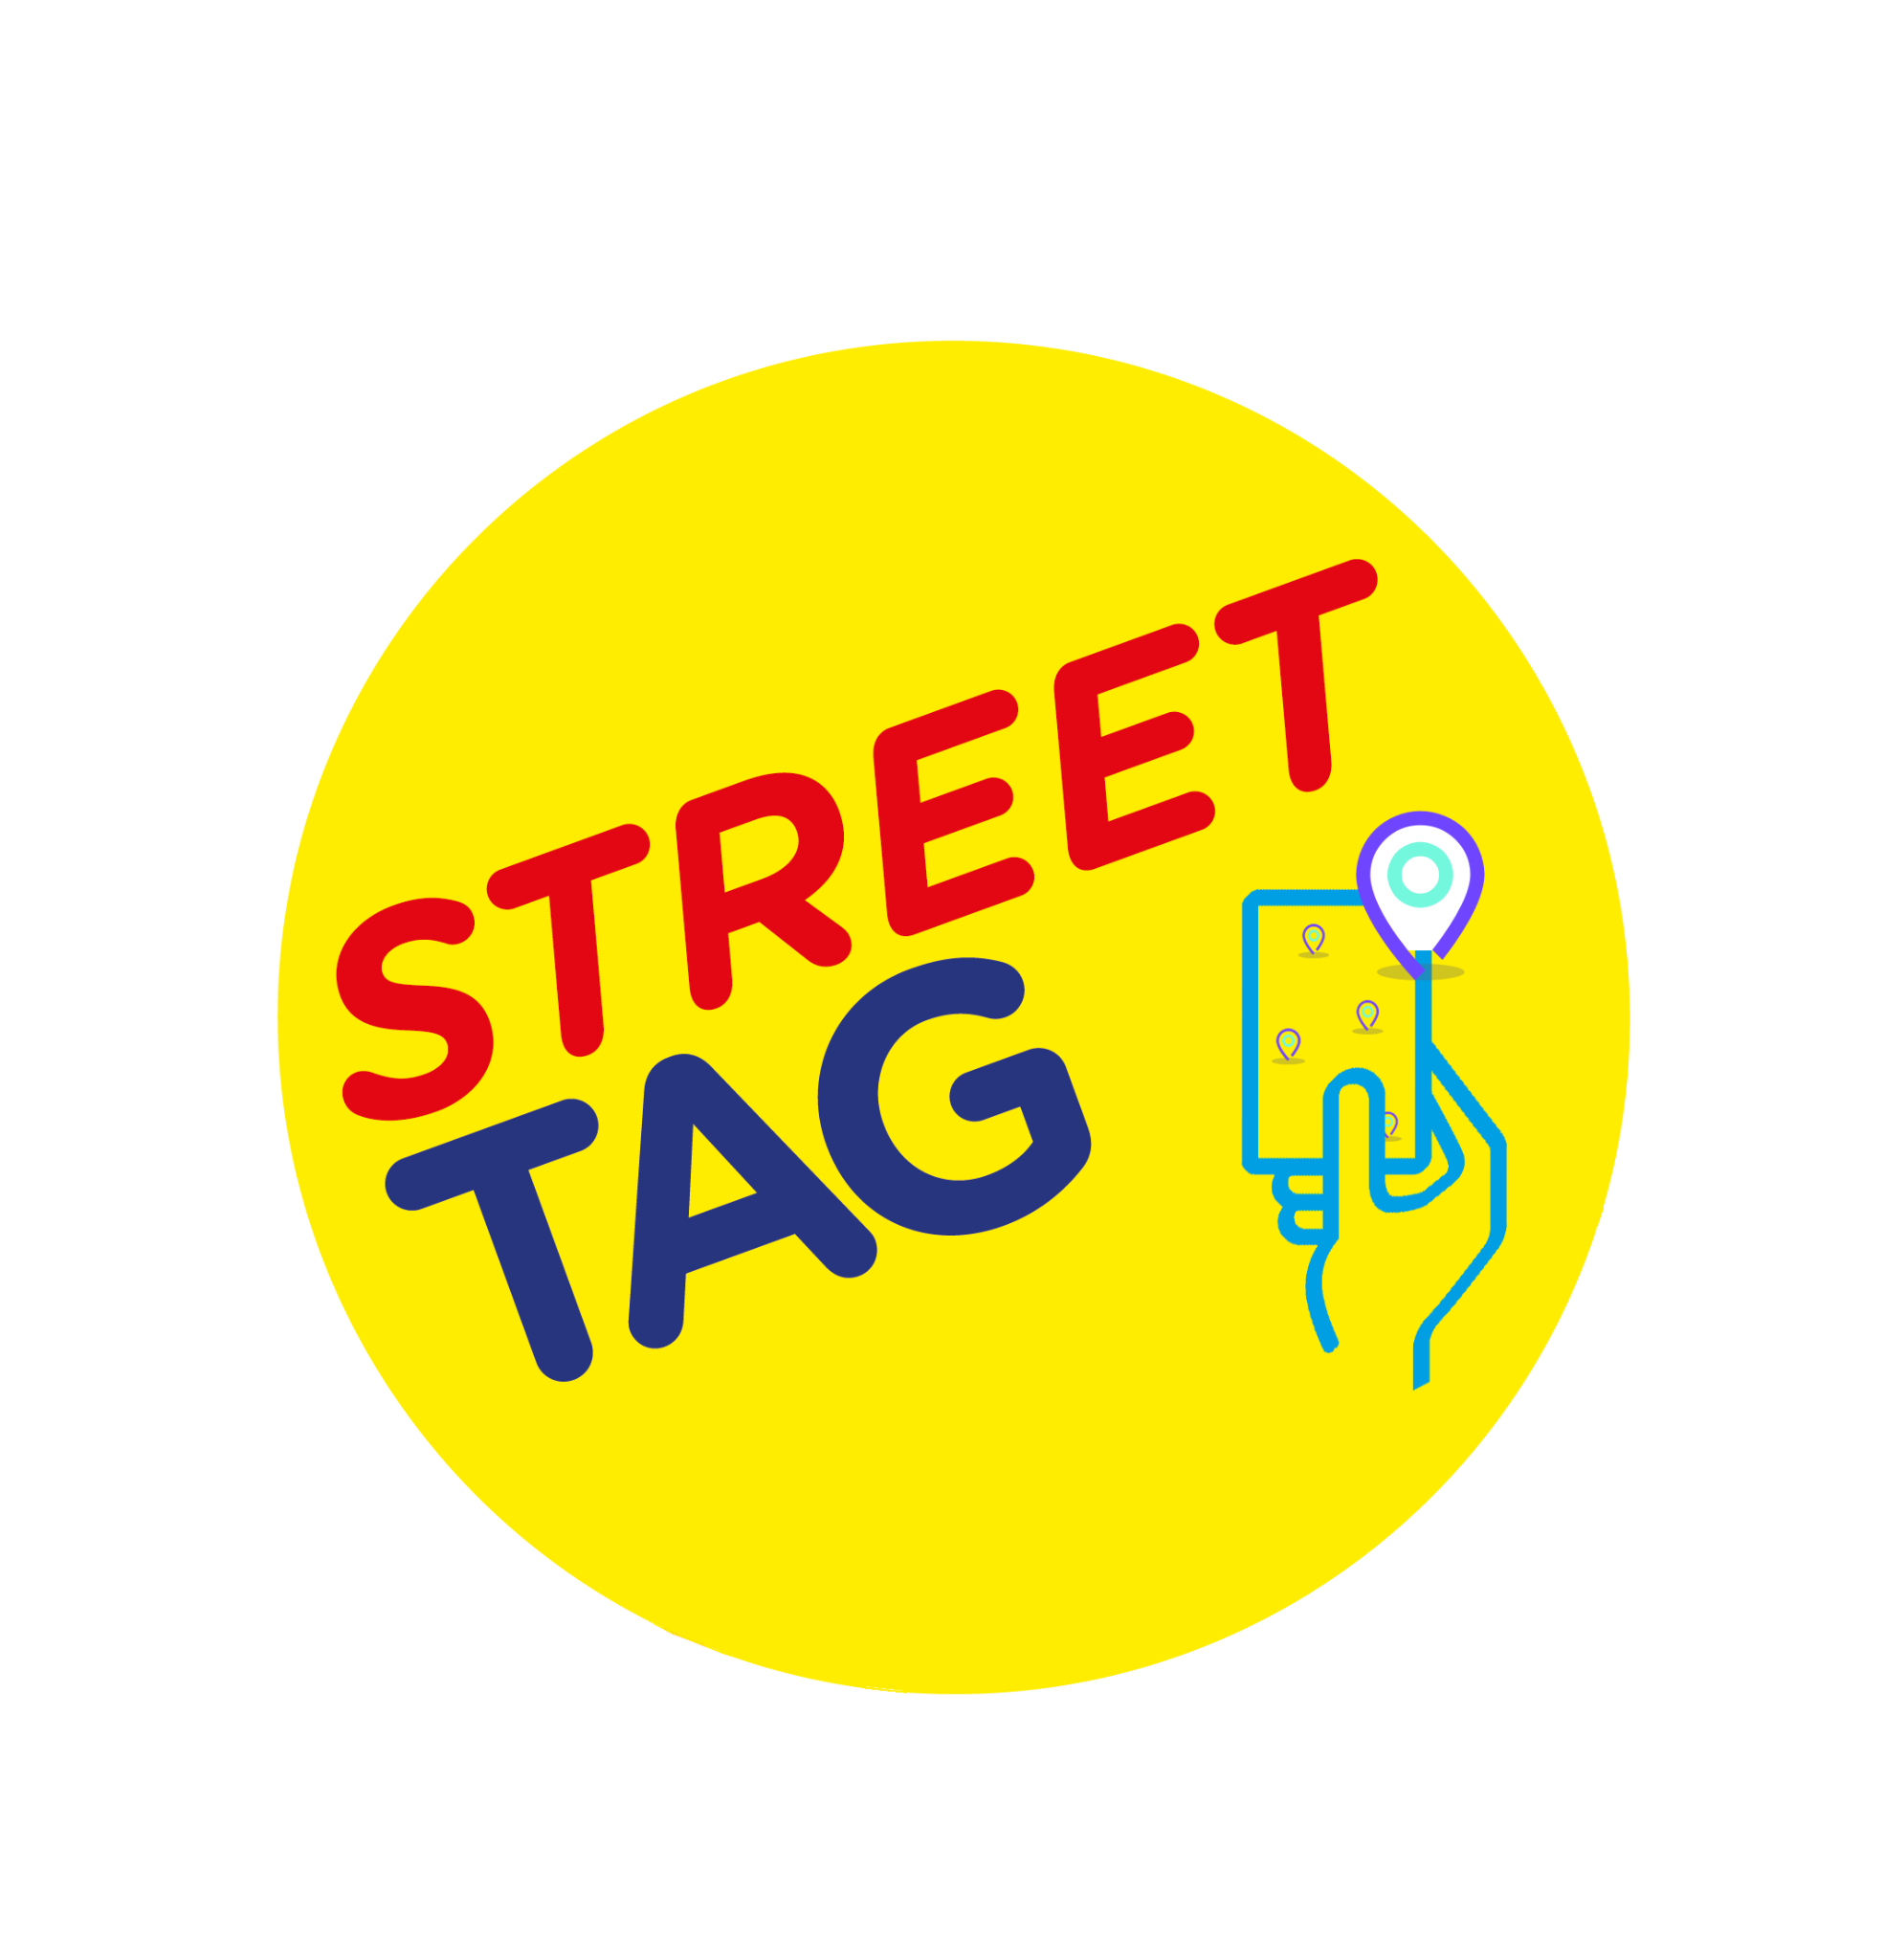

Q: How much cost is involved to get our school onboard on the program?
A. It is FREE for your school to participate.
Your school can have up to 250 participants in your school team (these can include parents, children, and staff).

Q. What happens if the school team is full of 250 participants? Can the school have more than one team?
A. A school can have more than 1 team once the initial team is full. Please let us know once your school team reaches 225 participants. We will release another new team with 250 places.
Please Note: Both teams will be counted as individual teams on the leaderboard. We cannot merge them at the end of the season.

Q: How does the school team earn points?
A. With Street Tag, participants record the distance they walk, run, or cycle by collecting virtual tags with their smartphone at various locations, watching their total distance accumulate to climb up their local Schools leaderboard; steps are converted into points by syncing their steps into the Street Tag app.
This is designed to encourage families to walk and cycle to school, to be physically active, to connect with green spaces, and is an opportunity to rediscover their local area as well as earn rewards for their school.

Q: How long does one season last?
A. Each season runs for 5weeks.

Q. Does the (app) work on other devices such as laptops, tablets, and iPads?
A. The Street Tag app is only available on the Apple IOS store and the Google Play Store. The app can be used on any device that runs the mobile operating system of these two platforms, this includes but is not limited to Android phones, iPhones, the iPad, and some Android tablets with the right specifications of the Android operating system.

Q. Will the app work without the internet?
Yes, the app works in offline mode.

Q: How can a parent join a school team?
- Steps to Join a School Team: ( For a parent/ guardian/carer)

1. Install the app from Play Store/ App Store, open it and click on Sign up.
2. Enter the valid details to Sign up - full name, username, email Id, and password, then click continue.
3. Select the School Leaderboard from the leaderboard options and click continue.
4. Select the Schools leaderboard (Borough/ District / SGO area) from the given list, then pick your school team from the list and click continue.
5. Enter your preferred gender, and you can fill in the other optional details if you want. Then click on Sign Up.
6. Verify with your Email/ Phone number.
7. After the verification step, please answer the questionnaire.
8. Congratulations! Your account is ready for use.

Q: How to add a child to a parent account?

Create an Email ID for your child.
A parent can add a max of 2 children as players C1 and C2.
Click on the 'Add a child' icon in the settings of the app.
Fill in all the details to add a player.
Go to the app Settings > click Profile.
Select your C1 and C2 option and click add to complete activation.
Once a child is added as a player. You will see the C1/ C2 option appear on the main map home screen.
While tagging with your children, please click/tap on C1/C2 to collect a tag for them.

Q: If a parent of primary-age children adds 2 children to their account, does that count as one participant (as one account) out of the 250 max for a school or two?

A. This will count as three accounts. As each account is still unique with its profile, points accumulate even if they are connected to one parent or guardian account.

Q: How do we check our school team points?
A. You can check your points by visiting the Leaderboard accessible through the side menu, alternatively, click the dashboard icon at the top of the home map screen.

Q: How to use your child account connected to your main account on Street Tag?
A. Your account (Parent/ guardian) will Auto Collect, however, to collect points for C1 or C2, you have to tap the C1/C2 button for each tag to collect for the child account.

Q: How do you create tags where there aren’t any?
A. 1. Please stand at the location where you want to create new tags.
2. From the app’s map home screen, click on the ‘create tags’ button at the top of the screen.
3. Click the “I’m awesome, give me tags” button.
4. The app will create new tags for you if there aren’t enough existing tags around.

Q. Can players be on two leaderboards simultaneously?
Currently, a user can’t be on more than one leaderboard at a time. In the future, we are exploring how residents participating in the community leaderboard can assign a local school to their account for their community leaderboard points to go towards, rather than having to leave the community leaderboard to join a school leaderboard.

Q. How secure is the app if the app requires the internet and location to work?
A. The Street Tag app is secured with the use of appropriate encryption, and other security measures are also in place to protect the data and privacy of users on the Street Tag app, including following the GDPR guidelines.

Q. Primary school team is made up of families and staff, with parents able to register two children each. What about single parents with more than 3 children?

A.We have launched the addition of TAG fobs to collect tags which are available for families whereby they can have an additional fob to tap on their phone after they have already added 2 children to their main smartphone account. Fobs can be ordered through our website www.streettag.co.uk

Q. Do I have privacy on Street Tag?
- Yes, you've 100% privacy on Street Tag

Q. Do I have control over my activities on the app Street Tag?
- You're in full control of your activities on our app, your timestamps are accessible only by you, and can be cleared anytime by you from the app settings.

Q. Can other users communicate with me through the Street Tag app?
- There's no way for anyone to communicate with you within our app. Only the street tag team sends push notifications from the backend.

Q. Does Street Tag sell adverts on the app?
- No, we don't sell adverts on the app. It’s 100% ads-free.

Q. Can Street Tag track my movement on the app?
- We don’t track users' movement on our app.

Q. Can other users know my location on the app?
- It's absolutely impossible for other users to view or know other users' locations on the app.

Q. Where can I go to get more details about Street Tag’s privacy policy?
- For further details about our privacy policy, please find Street tag's privacy policy on our website here https://www.streettag.co.uk/privacy-policy/

